|  |
| --- |
| Homework 1 |
| carlos guisaoCOP5339January 21, 2018 |

1

Write a Java program that calculates and displays the Fibonacci

series, defined by the recursive formula F(n) = F(n-1) + F(n-2).

F(0) and F(1) are given on the command line.

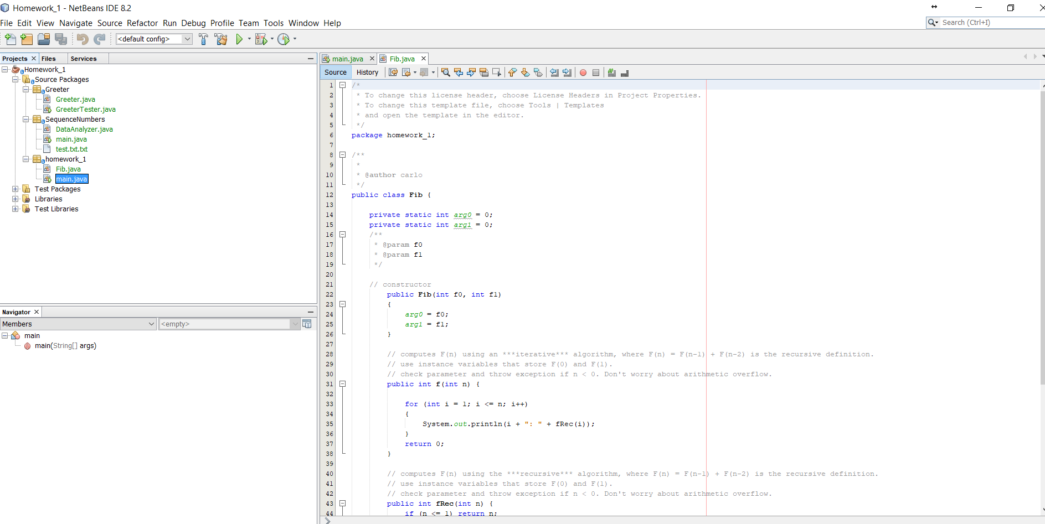

Fib Class

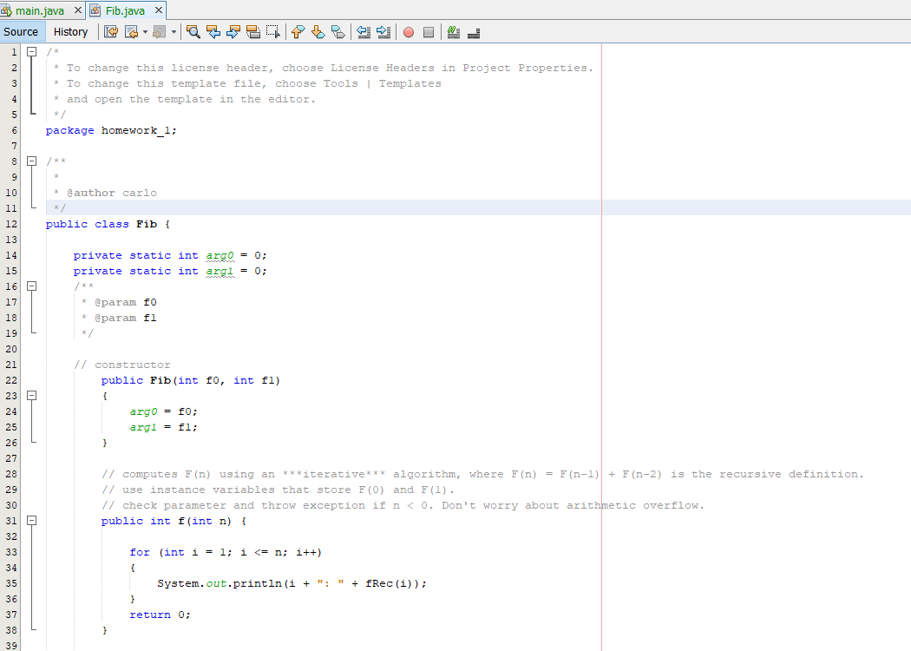

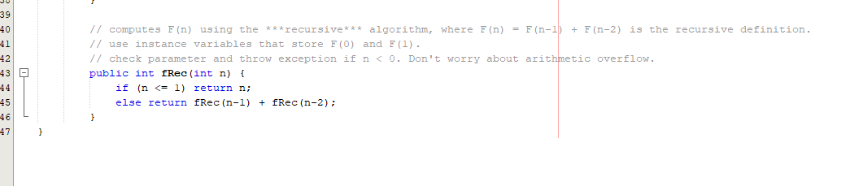

Main Class

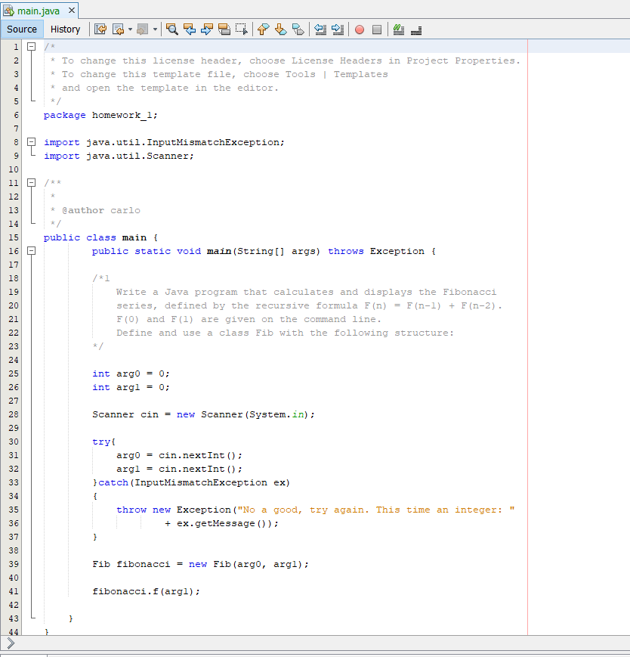

Results:

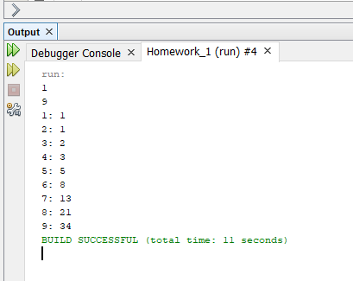

Write javadoc comments for the Fib class

2

a. Write a new method for the Greeter class,

public void swapNames(Greeter other) {...}

that swaps the names of this greeter and another instance.

b. write a new method for the Greeter class:

public Greeter createQualifiedGreeter(String qualifier) { ..... }

that returns a new Greeter object with its name being the qualifier string followed by

" " and the executing greeter's name (i.e. this.name).

For example:

Greeter g = new Greeter("world");

Greeter g2 = g.createQualifiedGreeter("beautiful");

g2.name will be the string "beautiful world"

c. Write a GreeterTester class that shows how the swapNames() and the createQualifiedGreeter()

methods are used.

Greeter:

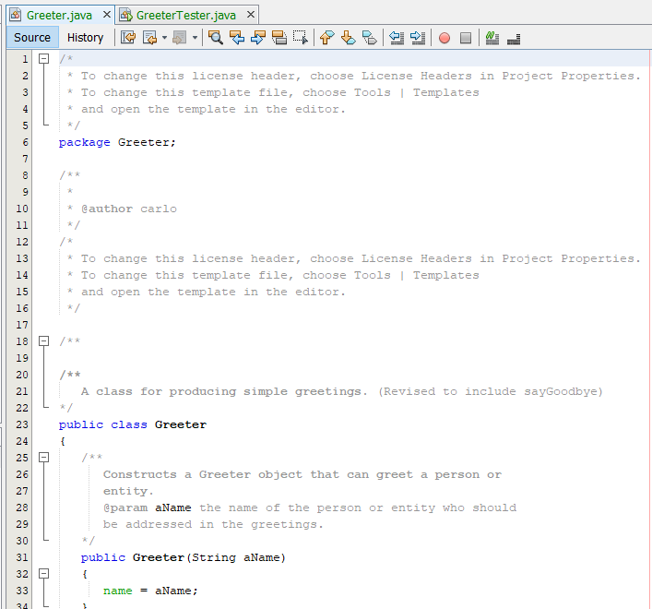

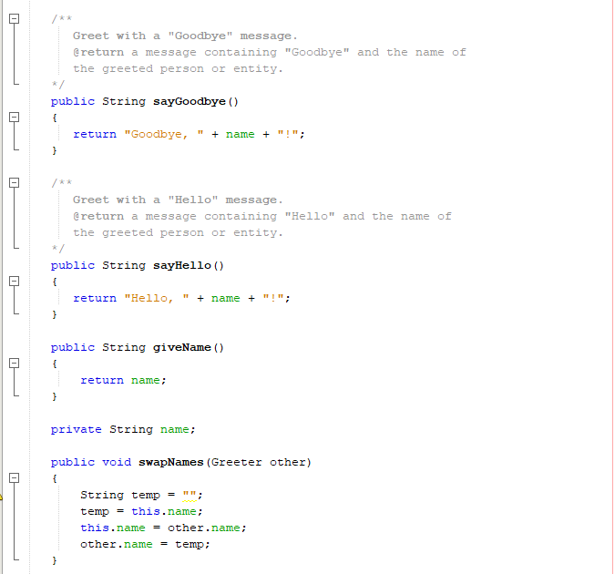

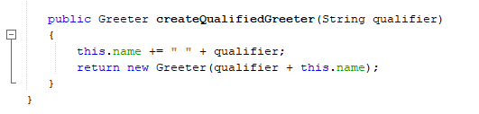

Greeter Tester

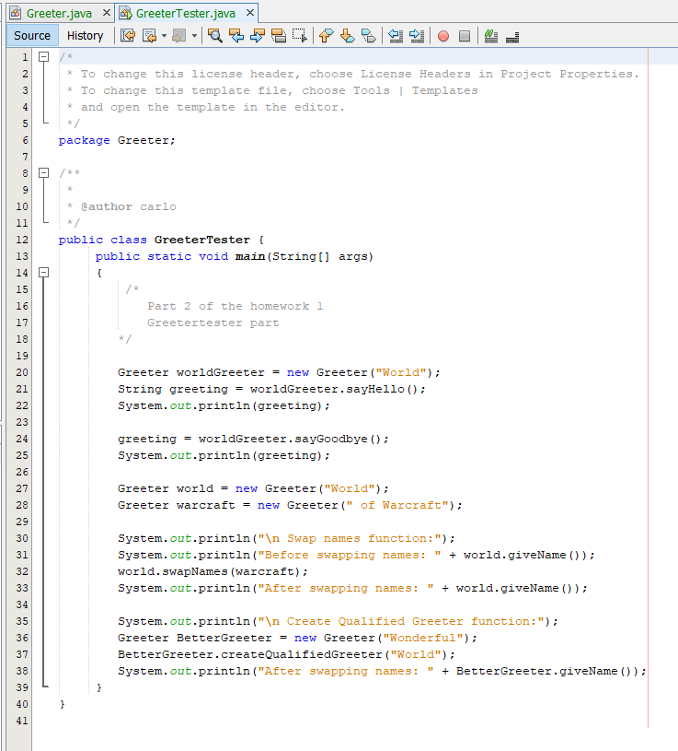

Results:

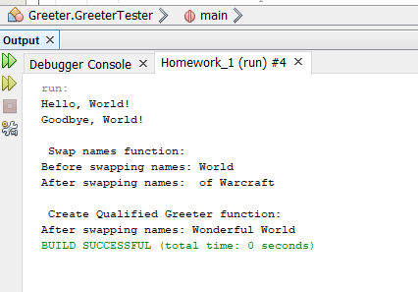

Write a program that:

a. reads from the terminal a sequence of numbers (integers)

b. saves them to a file with the name given from the command line

c. calculates,then displays on the terminal, and also saves to that file

the maximum, minimum, and average.

Additional requirements:

Store the numbers in a LinkedList<Integer>.

Define a class DataAnalyzer that

* has a constructor that stores the list of numbers:

public DataAnalyzer(LinkedList<Integer> numList) {...}

* has a method each for computing min(), max() and average():

public int min() {...}, etc.

Define a class DataAnalyzerTester that reads the numbers from System.in, builds the number list,

creates the DataAnalyzer object, and displays the min, max, and average using the DataAnalyzer instance.

The DataAnalyzerTester class implements the main() method.

Your code needs to handle invalid input and I/O exceptions.

Write javadoc comments.

Include both java files in your solution document.

Data Analyzer:

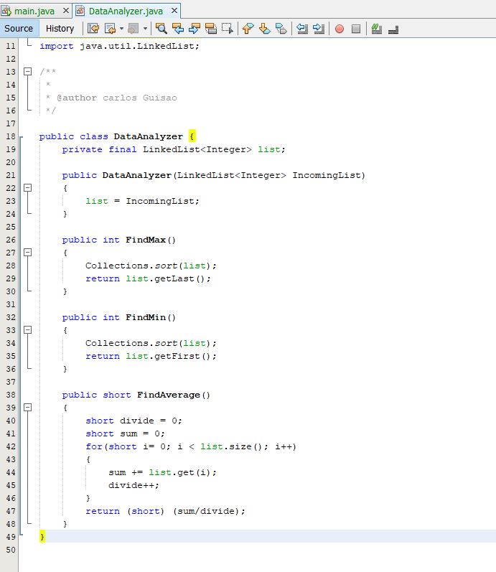

Main:

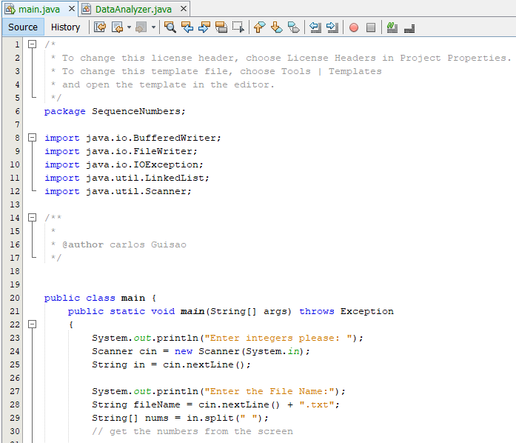

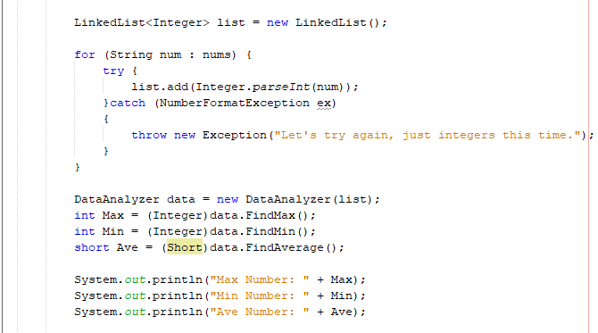

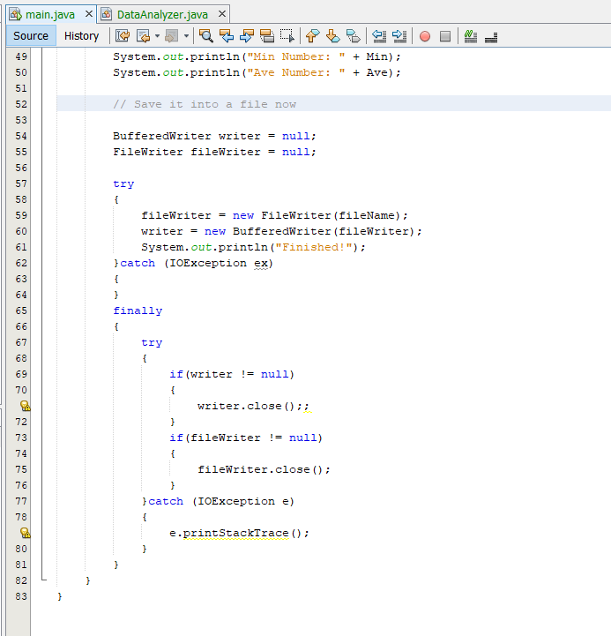

Answer:

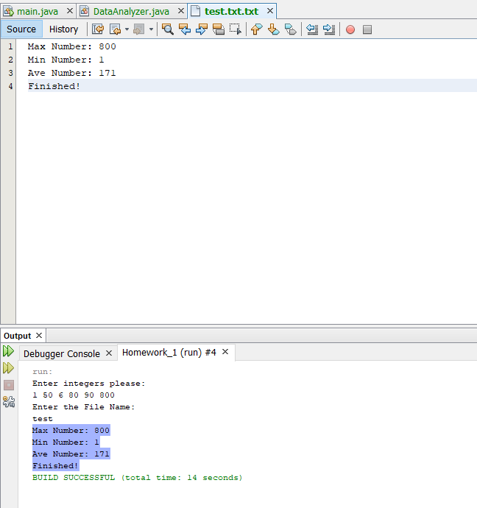

4.

Answer the question and explain what happens without running the code:

What is the value of x after the following code is executed ?

I believe that the answer is 3, once all of the objects are created the conditions of the if statements are true. Then the operator “==” checks when two objects are equal; but in this case, they are not, which only means that g2==null is excited. Once the print out for q2 calls the method SayHello(), which produces a null reference and then the catch block gets the value ++ and finally increases by another 1.